## **Project Overview**

This project analyzes Uber trip data obtained from Kaggle. The goal was to uncover insights into **vehicle usage, trip locations, and travel trends** through data cleaning, modeling, and visualization. The final deliverable is an **interactive Power BI dashboard** that summarizes the findings in a clear and engaging way.

## **🔍 Steps Taken**

1. **Data Source**
   * Dataset: Uber Trips – Kaggle
   * Format: CSV
2. **Data Cleaning & Preparation**
   * Removed duplicates and missing values
   * Standardized column names and formats (dates, vehicle types, locations)
   * Created derived fields where necessary
3. **Modeling in Power BI**
   * Imported the cleaned dataset into Power BI
   * Built relationships between relevant fields (date, vehicle, location)
   * Created calculated columns & measures using **DAX**
4. **Analysis & Key Metrics**
   * Trips by **vehicle type**
   * Trips by **location/region**
   * **Trends over time** (daily, weekly, monthly usage)
5. **Dashboard Creation**
   * Designed an interactive Power BI dashboard with:  
     + KPIs for total trips, unique vehicles, etc.
     + Bar/line charts for trends
     + Maps for trip locations
     + Filters/slicers for deeper exploration

## **📊 Dashboard Preview**

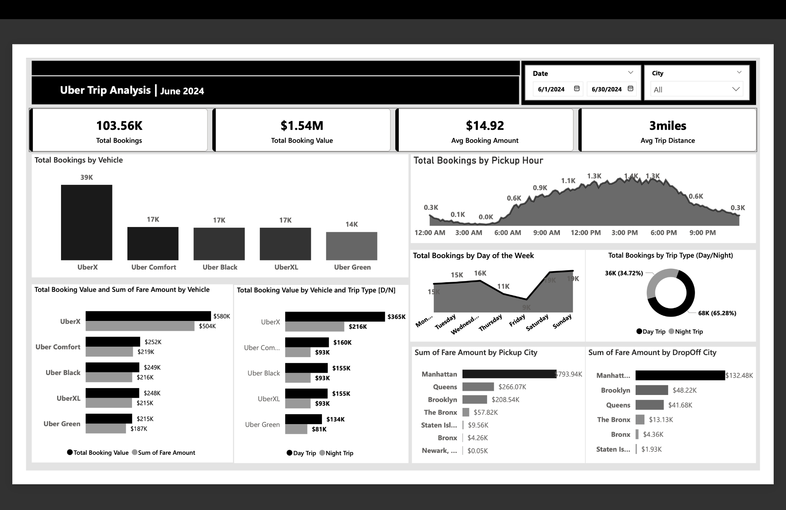

## **🛠 Tools & Technologies**

* **Power BI** – Data modeling & dashboard creation
* **DAX** – Measures and calculated fields
* **Excel / Python (optional)** – Data cleaning (if you used them)
* **Kaggle** – Dataset source

## **🚀 How to Use**

1. Open the .pbix file in Power BI Desktop
2. Explore the dashboard and interact with filters

## **📈 Key Learnings**

* Hands-on experience with data cleaning and transformation
* Applying DAX for calculations and insights
* Building a user-friendly interactive dashboard
* Storytelling with data using visuals

## **📬 Contact**

If you’d like to connect or collaborate:

* LinkedIn: [Sulleiman Musah](https://www.linkedin.com/in/sulleiman-musah-28a901374)
* Email: your.musahsulley551@gmail.com